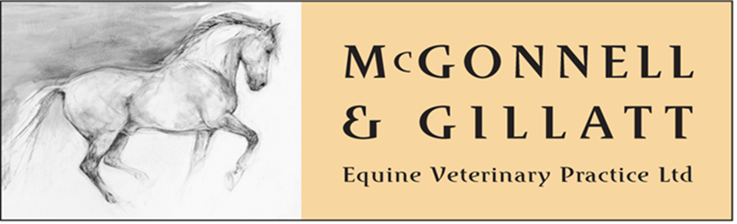
Pre-Purchase Vetting Enquiry Form
Please complete the following form and email to: office@mghorsevets.co.uk. A member of the Team will then call you to discuss arrangements

Name of Purchaser:

Address of Purchaser:

Contact Telephone No:

Name of Vendor:

Address of Vendor:

Contact Telephone No:

Address of Vetting:
(if different to above)

HORSE DETAILS
Name | Age | Colour | Gender | Breed/Type | Height

Purpose Required for (please indicate):
General riding | Show jumping | PC Activities | Hunting
Dressage | Endurance | Racing | Eventing
Showing | RC Activities | Polo
Any other (please indicate)

Type of Vetting required:
Two Stage
Five Stage
Insurance / Mortality

Do you require X-Rays to be taken at the Vetting?

Please ensure the horse is stabled one hour prior to the vetting
A rider will be required for a five stage vetting (unbroken horses can be lunged)
Please find out when the horse last received farrier attention.

